**E-COMMERCE GAS SHOP**

Software Requirement Specification

Developing a building material sales system

Version 1.0.0

Guided by: Nguyễn Thành Ý

Written by: Group 4_SE1706

# Revision History

|  |  |  |  |
| --- | --- | --- | --- |
| **Date** | **Description** | **Author** | **Comments** |
| 8/01/2023 | Version 1 | Nguyễn Văn A,.. | <First Revision> |
|  |  |  |  |

# Document Approval

The following Software Requirements Specification has been accepted and approved by the following:

|  |  |  |  |
| --- | --- | --- | --- |
| **Signature** | **Printed Name** | **Title** | **Date** |
|  |  |  |  |
|  |  |  |  |
|  |  |  |  |

# Table of Content

Revision History 2

Document Approval 2

Table of Content 3

1 Introdution. 5

1.1 Overview 5

1.2 Purpose 5

1.3 Scope 5

1.4 Definitions, Acronyms, and Abbreviations 5

1.5 General 6

2 General Description 6

2.1 Product Perspective 6

2.2 Product Functions 6

2.3 User characteristic 7

2.4 Assumptions and Dependencies 7

2.5 General Constraints 8

3 Specific Requirements 9

3.1 External Interface Requirements 9

3.1.1 User Interfaces 9

3.1.2 Hardware Interfaces 9

3.1.3 Software Interfaces 9

3.1.4 Communications Interfaces 9

3.2 User Case 10

3.3 Function Requirement 10

3.3.1 System Functional Overview 10

1. Screens Flow 10

2. Screen Descriptions 10

3. Screen Authorization 10

3.3.2 Sale Management 12

4. View Recent Sales 12

5. View Recent Sales 12

6. View Sales Details 13

7. View Today Sales 14

8. View Montly Sales 14

9. View Last Year Sales 15

10. View Yearly Sales 15

3.3.3 Login Management 16

11. Login 16

12. Login bằng tài khoản google 16

3.3.4 Customers Management 18

13. View Customer List 18

14. Search name customer in Customer List 19

15. Sort customer in Customer List 20

16. Delete customer in Customer List 21

17. Update customer in Customer List 22

3.3.5 News Management 23

18. Modify News 23

19. Delete News 25

20. Create News 26

3.3.6 Product Management 28

3.4 Non-Functional Requirements 38

3.4.1 Performance 38

3.4.2 Availability 38

3.4.3 Security 38

3.5 Inverse Requirements 38

3.6 Design Constraints 38

3.7 Logical Database Requirements 38

3.8 Other Requirements 38

A. Appendices 38

A.1 Business Rule 38

A.2 References 38

# Introdution.

## Overview

The e-commerce gas shop software system aims to provide a user-friendly online platform for customers to purchase gas products conveniently. It serves as a digital marketplace connecting gas suppliers with end-users, facilitating seamless transactions and efficient order management. The software system will be developed to support the operations of a gas shop, offering a wide range of gas products, secure payment processing, and inventory management capabilities.

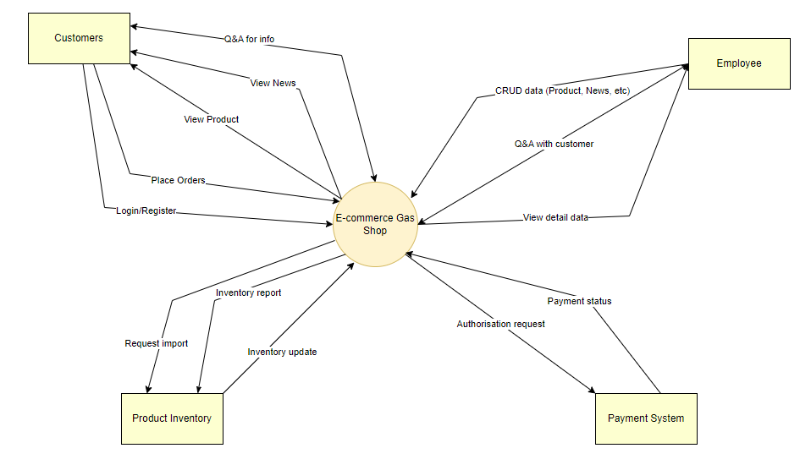

## Purpose

* Project of a website to sell gas products, gas cylinders, and equipment associated with the product, built with the aim of providing customers with high quality products. and full of convenient features, helping customers easily search, compare, choose and buy the necessary products for themselves.
* This document will be used to develop the software requirements specification document, helping to ensure that the software developed meets the product's specification and feature requirements. In addition, the document provides the necessary information to develop new features and enhance the customer experience on this sales site.

## Scope

The purpose of this Software Requirements Specification (SRS) document is to define the requirements for the development of an e-commerce gas shop. The SRS serves as a comprehensive guide and reference for all stakeholders involved in the project, including the development team, project managers, clients, and users. This document aims to establish a clear understanding of the desired features, functionalities, and behavior of the e-commerce gas shop software system. It outlines the scope of the project, identifies the target audience, and provides detailed specifications for both functional and non-functional requirements. The SRS acts as a contractual agreement between the development team and the client, ensuring that the developed software system meets the expectations and needs of the gas shop owner, customers, and gas suppliers. Overall, the purpose of this SRS is to provide a clear and comprehensive specification of the e-commerce gas shop, guiding the development team in building a reliable, scalable, and user-friendly software solution that meets the business objectives of the gas shop owner and delivers a seamless experience for customers and gas suppliers.

## Definitions, Acronyms, and Abbreviations

|  |  |
| --- | --- |
| SRS | Software Requirements Specifications |
| BR | Business Rule |
| UI | User Interface |
| N/A | Not applicate, not available |
| User Case(s) | Diagram describe system requirements |

## General

This document is written in accordance with the Software Requirements Specifications (SRS) described in the "IEEE Recommended Practice for Software Requirements Specifications" and the "IEEE Guide for Developing System Requirements Specifications".

With the structure divided into three parts:

1. Part 1: Provides an overview of the components of SRS.
2. Part 2: An overview of the factors, constraints, user characteristics, execution environment that impact the system and its requirements. Provides detailed information on functional requirements, providing software developers with information to develop software that meets those requirements.
3. Part 3: Non-functional requirements.

# General Description

## Product Perspective

The e-commerce gas shop software system is designed to operate as an independent web-based application, functioning as a standalone platform for customers to browse and purchase gas products.

## Product Functions

* Guest: Customers have the right to view product and service information of the online store, place orders and pay for their orders. Customers are also responsible for providing secure that their personal and payment information.
* User: Customer has the right to register and log in to an account, view order history, manage personal information, perform activities on the website such as placing orders, discussing with customer support staff and product reviews. The customer is also responsible for performing activities on the website in accordance with the regulations of the online store. Customers buy products with warranty cards and bring the products for warranty when they encounter errors.
* Administrator: Administrator has access to and manages the entire operation of the online store, including product management, orders, customer information, employee information, coupons, interface of the e-commerce shop. The administrator is also responsible for administering the operation of the online store to be carried out in accordance with regulations, protecting the personal information and customer orders. The administrator also has the right to delete the product when the error is reported beyond the specified limit.
* Employee: Employee has the right to access to and manage some of the feature of the online store management, including product management, customers information, sales detail,… depends on the role of the employee. Employee must follow the store policies and the direction of the administrators.

## User characteristic

The system consists of agents who are Guest, Customer, Employee and Administrator.

* Guest: This is a user who visits the website and performs activities on the website, but has not registered for an account. Guest can view product information, prices and policies of the online store.
* Customer: This is a user who has registered an account on the website and can log in to use the website's functions such as placing orders, viewing order history, managing personal information and registering to receive news. instant, promotion from online store. The customer's role is to be the consumer of the online store's products and services. Customers can bring the product to warranty when the product has a fault.
* Administrator: This is the person who manages and runs the entire operation of the online store, including tasks such as product management, order management, customer information management, Store activity statistics. The administrator's role is to ensure that the operations of the online store are carried out efficiently, that the customer needs are met, and that the store's business goals are achieved. Will evaluate the product when the product is brought to the warranty beyond the specified.
* Employee: This is the person who performs parts of an administrator role. The employee’s role is to keep track of the online store and perform tasks based on the administrator requirements.

## Assumptions and Dependencies

* The user should have fufficient knowledge about computers
* The computer should have an internet connection and buternet server capabilities
* The user speak the English language, as the interface with be provided in English

## General Constraints

The e-commerce gas shop software system is subject to various constraints that will impact the design and development process. These constraints include corporate policies, regulatory requirements, hardware limitations, interfaces, technologies, security considerations, and design conventions. It is essential to consider these constraints during system development. The general constraints are as follows:

1. Interfaces to Other Applications:
   * The e-commerce gas shop may need to integrate with external applications or systems, such as payment gateways, shipping providers, or inventory management systems. The interfaces and integration protocols should be considered during the design and development process.
2. Parallel Operations:
   * The e-commerce gas shop may need to support concurrent operations, such as multiple customers browsing the website, placing orders, and updating inventory simultaneously. The system should be designed to handle parallel operations effectively and maintain data consistency.
3. Language Requirements:
   * The user interfaces and content of the e-commerce gas shop should support the required languages and character sets as defined by the gas shop owner or the target market.
4. Communications Protocols:
   * The system should comply with established communications protocols, such as HTTP/HTTPS for web interactions and secure data transmission.
5. Security Considerations:
   * The e-commerce gas shop should incorporate appropriate security measures to protect user data, prevent unauthorized access, and ensure secure transactions. This may include encryption, user authentication, secure storage of sensitive information, and protection against common security threats.

# Specific Requirements

## External Interface Requirements

### User Interfaces

Ul-1: The website header will include the website's logo, address, phone number, and main categories: The middle of the page displays the products, the bottom of the page is divided into newsgroups (warranty policy, promotions.

Ul-2: The interface is suitable for display on computers and phones

U-3: Use icons to provide more detail to users.

U-4: The main color of the website is green

### Hardware Interfaces

No hardware interfaces have been identified

### Software Interfaces

I The website does not integrate other commercial software

### Communications Interfaces

The web browser will entomatically log out if the user does not use the system within 30s

## User Case

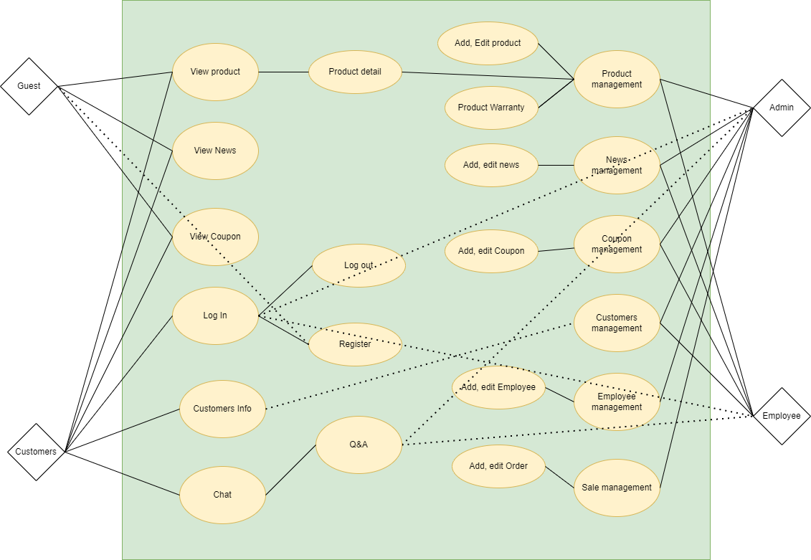

3.2 1 Overview use Case

## Function Requirement

### System Functional Overview

#### Screens Flow

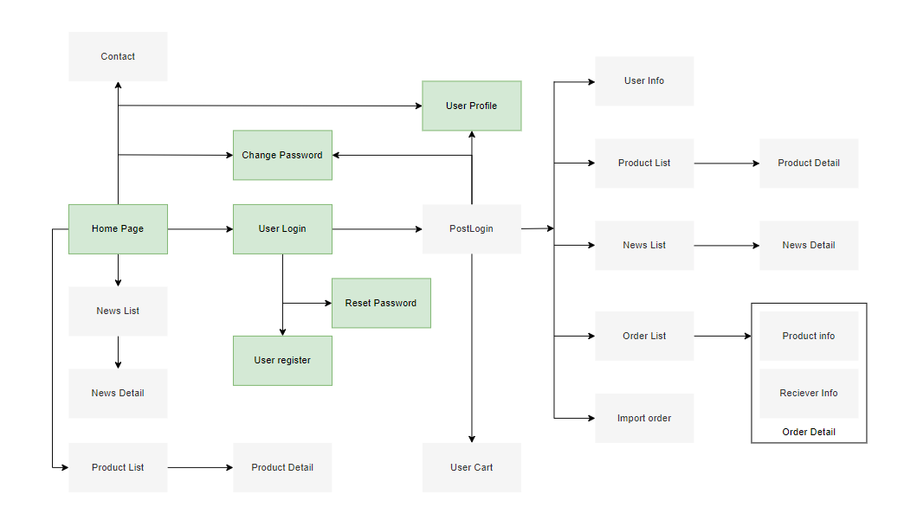

#### Screen Descriptions

#### Screen Authorization

|  |  |  |  |  |
| --- | --- | --- | --- | --- |
| **Screen** | **Admin** | **Employee** | **Customer** | **Guest** |
| **Home Page** | X | X | X | X |
| **Product List** | X | X | X | X |
| **Product Details** | X | X | X | X |
| **Active/Deactive an Employee** | X |  |  |  |
| **View his/her orders** |  |  | X |  |
| **Employee Edit** | X | X |  |  |
| **News List** | X | X | X | X |
| **Add News** | X | X |  |  |
| **News Details** | X | X | X | X |
| **Edit News information** | X | X |  |  |
| **Coupon List** | X | X |  |  |
| **Coupon Details** | X | X | X | X |
| **Add new Coupon** | X | X |  |  |
| **Update Coupon** |  | X |  |  |
| **User Login** | X | X | X | X |
| **User Register** | X | X | X | X |
| **Forgot Password** | X | X | X | X |
| **Change Password** | X | X | X | X |
| **User Profile** | X | X | X |  |
| **Accounts List** | X |  |  |  |
| **Account Details** | X |  |  |  |
| **Customers List** |  | X |  |  |
| **Customers Details** |  | X |  |  |
| **Settings List** | X |  |  |  |
| **Setting Details** | X |  |  |  |
| **Book Appointment** |  |  | X |  |
| **Reserve a Service** |  |  |  |  |
| **Appointment History** | X | X | X |  |
| **Reservation History** |  |  |  |  |

### Sale Management

#### View Recent Sales

|  |  |  |  |
| --- | --- | --- | --- |
| **Name** | **View Recent Sales** | | |
| Created By: | Minhnq | Date Created: | 16-5-2023 |
| Primary Actor: | Admin | Other Actors: |  |
| Trigger: | Actor logins to the system | | |
| Description: | Actor can view the list of 7 most recent sales | | |
| Preconditions: | Actor must login first and have permission to access the General Page | | |
| Postconditions: | System will display the list of 7 recent sales | | |
| Normal Flow: | 1. Enter Admin account to login 2. The system checks for Admin’s permission from the database 3. If Admin has the permission, the system would display the list of recent sales. Additionally, there will be a “Show All” button at the right corner of the table and a “Details” button next to every order displayed. | | |
| Alternative Flows: | N/A | | |
| Exceptions: | N/a | | |

#### View All Sales

|  |  |  |  |
| --- | --- | --- | --- |
| **Name** | **View All Sales** | | |
| Created By: | Minhnq | Date Created: | 16-5-2023 |
| Primary Actor: | Admin | Other Actors: |  |
| Trigger: | Actor clicks the “Show All” button at the right corner of the “View Recent Sales” table | | |
| Description: | Actor can view the list of all sales in history | | |
| Preconditions: | Actor must login first and have permission to access the General Page | | |
| Postconditions: | System will display the list of 7 recent sales | | |
| Normal Flow: | 1. Enter Admin account to login 2. The system checks for Admin’s permission from the database 3. If Admin has the permission, the system would display the list of recent sales along with the total income of the day, month, last year and this year. Additionally, there will be a “Show All” button at the right corner of the table. 4. Actor clicks on the “Show All” button and gets redirected to a new page displaying the list of all sales in history and along with the total income of the day, month, last year and this year. Additionally, there is a “Details” button next to every order displayed. | | |
| Alternative Flows: | N/A | | |
| Exceptions: | N/a | | |

#### View Sales Details

|  |  |  |  |
| --- | --- | --- | --- |
| **Name** | **View Sale Details** | | |
| Created By: | Minhnq | Date Created: | 16-5-2023 |
| Primary Actor: | Admin | Other Actors: |  |
| Trigger: | Actor clicks the “Details” button that is displayed next to every order in the list | | |
| Description: | Actor can view the bill regarding the order | | |
| Preconditions: | Actor must login first and have permission to access the General Page | | |
| Postconditions: | System will display the detail information of the corresponding order | | |
| Normal Flow: | 1. Enter Admin account to login 2. The system checks for Admin’s permission from the database 3. If Admin has the permission, the system would display the list of recent sales along with the total income of the day, month, last year and this year. Additionally, there will be a “Show All” button at the right corner of the table. 4. Actor clicks on the “Show All” button and gets redirected to a new page displaying the list of all sales in history and along with the total income of the day, month, last year and this year. Additionally, there is a “Details” button next to every order displayed. 5. Actor clicks on the “Details” button next to an order 6. The system displays details of the order in the form of a bill corresponding to the chosen order | | |
| Alternative Flows: | N/A | | |
| Exceptions: | N/a | | |

|  |  |  |  |
| --- | --- | --- | --- |
| Created By: | Minhnq | Date Created: | 17-5-2023 |
| Primary Actor: | Admin | Other Actors: |  |
| Trigger: | Actor clicks on the “Yearly Sale” button that is displayed at the top of the General Page | | |
| Description: | Actor can view the list of year being made this year | | |
| Preconditions: | Actor must login first and have permission to access the General Page | | |
| Postconditions: | System will display the list of this year’s sale | | |
| Normal Flow: | 1. Enter Admin account to login 2. The system checks for Admin’s permission from the database 3. If Admin has the permission, the system would display the content of the General Page. 4. Actor clicks “Yearly Sale” button that is displayed at the top of the General Page 5. The system displays the list of this year’s sales as well as the total income of the day, month, last year and this year. Additionally, there is a “Details” button next to every order displayed. | | |
| Alternative Flows: | N/A | | |
| Exceptions: | N/a | | |

m

#### View Today Sales

|  |  |  |  |
| --- | --- | --- | --- |
| **Name** | **View Today Sale** | | |
| Created By: | Minhnq | Date Created: | 17-5-2023 |
| Primary Actor: | Admin | Other Actors: |  |
| Trigger: | Actor clicks on the “Today Sale” button that is displayed at the top of the General Page | | |
| Description: | Actor can view the list of sales being made today | | |
| Preconditions: | Actor must login first and have permission to access the General Page | | |
| Postconditions: | System will display the list of today’s sale | | |
| Normal Flow: | 1. Enter Admin account to login 2. The system checks for Admin’s permission from the database 3. If Admin has the permission, the system would display the content of the General Page. 4. Actor clicks “Today Sale” button that is displayed at the top of the General Page 5. The system displays the list of today’s sale as well as the total income of the day, month, last year and this year. Additionally, there is a “Details” button next to every order displayed. | | |
| Alternative Flows: | N/A | | |
| Exceptions: | N/a | | |

#### View Montly Sales

|  |  |  |  |
| --- | --- | --- | --- |
| **Name** | **View Monthly Sale** | | |
| Created By: | Minhnq | Date Created: | 17-5-2023 |
| Primary Actor: | Admin | Other Actors: |  |
| Trigger: | Actor clicks on the “Monthly Sale” button that is displayed at the top of the General Page | | |
| Description: | Actor can view the list of sale being made this month | | |
| Preconditions: | Actor must login first and have permission to access the General Page | | |
| Postconditions: | System will display the list of this month’s sale | | |
| Normal Flow: | 1. Enter Admin account to login 2. The system checks for Admin’s permission from the database 3. If Admin has the permission, the system would display the content of the General Page. 4. Actor clicks “Monthly Sale” button that is displayed at the top of the General Page 5. The system displays the list of this month’s sale as well as the total income of the day, month, last year and this year. Additionally, there is a “Details” button next to every order displayed. | | |
| Alternative Flows: | N/A | | |
| Exceptions: | N/a | | |

#### View Last Year Sales

|  |  |  |  |
| --- | --- | --- | --- |
| **Name** | **View Last Year Sale** | | |
| Created By: | Minhnq | Date Created: | 17-5-2023 |
| Primary Actor: | Admin | Other Actors: |  |
| Trigger: | Actor clicks on the “Last year sale” button that is displayed at the top of the General Page | | |
| Description: | Actor can view the list of sales made last year | | |
| Preconditions: | Actor must login first and have permission to access the General Page | | |
| Postconditions: | System will display the list of last year’s sale | | |
| Normal Flow: | 1. Enter Admin account to login 2. The system checks for Admin’s permission from the database 3. If Admin has the permission, the system would display the content of the General Page. 4. Actor clicks “Last year Sale” button that is displayed at the top of the General Page 5. The system displays the list of last year’s sales as well as the total income of the day, month, last year and this year. Additionally, there is a “Details” button next to every order displayed. | | |
| Alternative Flows: | N/A | | |
| Exceptions: | N/a | | |

#### View Yearly Sales

|  |  |  |  |
| --- | --- | --- | --- |
| **Name** | **View Yearly Sale** | | |
| Created By: | Minhnq | Date Created: | 17-5-2023 |
| Primary Actor: | Admin | Other Actors: |  |
| Trigger: | Actor clicks on the “Yearly Sale” button that is displayed at the top of the General Page | | |
| Description: | Actor can view the list of year being made this year | | |
| Preconditions: | Actor must login first and have permission to access the General Page | | |
| Postconditions: | System will display the list of this year’s sale | | |
| Normal Flow: | 1. Enter Admin account to login 2. The system checks for Admin’s permission from the database 3. If Admin has the permission, the system would display the content of the General Page. 4. Actor clicks “Yearly Sale” button that is displayed at the top of the General Page 5. The system displays the list of this year’s sales as well as the total income of the day, month, last year and this year. Additionally, there is a “Details” button next to every order displayed. | | |
| Alternative Flows: | N/A | | |
| Exceptions: | N/a | | |

### Login Management

#### Login

|  |  |  |  |
| --- | --- | --- | --- |
| **Name** | **Login** | | |
| Created By: | Minhnq | Date Created: | 17-5-2023 |
| Primary Actor: | Admin | Other Actors: |  |
| Trigger: | Actor starts the program | | |
| Description: | Actor can login to the system | | |
| Preconditions: | N/A | | |
| Postconditions: | Actor gain access to the program | | |
| Normal Flow: | 1. Actor enter the information for entrance 2. The system would go through the database to check whether the inputted information is valid 3. If valid, the system would go through the database again to check the role of the actor and create 3 session parameters being the admin’s id, name and role 4. Based on the admin’s role saved in the session, the page would be redirected accordingly | | |
| Alternative Flows: | 1. Actor enter the information for entrance 2. The system would go through the database to check whether the inputted information is valid 3. If not valid, the user would be redirected back to the login page | | |
| Exceptions: | N/a | | |

#### Login bằng tài khoản google

|  |  |  |  |
| --- | --- | --- | --- |
| **Name** | **Update customer in Customer List** | | |
| Created By: | ThinhNT | Date Created: | 8/06/2023 |
| Primary Actor: | Customer | Other Actors: |  |
| Trigger: | Customer click Google login button | | |
| Description: | Project will request Google API to get information of server then login with that account | | |
| Preconditions: | Server servlet must connect with Google | | |
| Postconditions: | System will alow customer to login with Google Account | | |
| Normal Flow: | Admin click the link to Login page  Admin click the Google login button  Software will request to Google API to get data, then Google will forward data to server  If customer haven’t login with that Google account yet, regist that account to data and immediately login | | |
| Alternative Flows: | N/A | | |
| Exceptions: | N/a | | |
| Priority: | Normal | | |
| Frequency of Use: | Usually | | |
| Business Rules: | Servlet must connect with Google API | | |
| Other Information: | N/A | | |
| Assumptions: | The actor’s internet connection is available | | |

### Customers Management

#### View Customer List

|  |  |  |  |
| --- | --- | --- | --- |
| **Name** | **View Customer List** | | |
| Created By: | ThinhNT | Date Created: | 13/05/2023 |
| Primary Actor: | Admin | Other Actors: | Employee |
| Trigger: | Actor click and Customer List will be shown up | | |
| Description: | Admin click and view list of customers | | |
| Preconditions: | Admin must log in first | | |
| Postconditions: | System will return a list of customer | | |
| Normal Flow: | Enter Admin account to login  Software display the general screen  Admin click Customer List  Software display detail of Customer List with 2 buttons “Update” and “Delete”, 1 input “Search” and 1 dropdown select “Search” | | |
| Alternative Flows: | N/A | | |
| Exceptions: | N/a | | |
| Priority: | Normal | | |
| Frequency of Use: | Usually | | |
| Business Rules: | Customer must have records in the storage and still be available  All information in the list must be clear and up-to-date. | | |
| Other Information: | N/A | | |
| Assumptions: | Actor’s internet connection is available | | |

#### Search name customer in Customer List

|  |  |  |  |
| --- | --- | --- | --- |
| **Name** | **Search name customer in Customer List** | | |
| Created By: | ThinhNT | Date Created: | 13/05/2023 |
| Primary Actor: | Admin | Other Actors: | Employee |
| Trigger: | Actor click to the search bar, input name need to search then click button Search to search | | |
| Description: | Admin search name of customer in list of customers | | |
| Preconditions: | Admin must be in Customer List page | | |
| Postconditions: | System will return customer who has been searched | | |
| Normal Flow: | Admin click the link to CustomerList  Admin click the search bar  Admin input name into search bar  Admin click “Search” Button  Software access to database to search the customer with the name have to search, then return that customer to screen | | |
| Alternative Flows: | N/A | | |
| Exceptions: | N/a | | |
| Priority: | Normal | | |
| Frequency of Use: | Usually | | |
| Business Rules: | Customer must have records in the storage and still be in Displayable status. | | |
| Other Information: | N/A | | |
| Assumptions: | Actor’s internet connection is available | | |

#### Sort customer in Customer List

|  |  |  |  |
| --- | --- | --- | --- |
| **Name** | **Sort customer in Customer List** | | |
| Created By: | ThinhNT | Date Created: | 13/05/2023 |
| Primary Actor: | Admin | Other Actors: | Employee |
| Trigger: | Actor click to the dropdown, select A-Z or Z-A or new or old Customer, then click Search Button | | |
| Description: | Admin sort customer in list of customers | | |
| Preconditions: | Admin must be in Customer List page | | |
| Postconditions: | System will sort the Customer List with condition then return the List | | |
| Normal Flow: | Admin click link to CustomerList  Admin click the option select dropdown  Admin click “Search” Button  Software access to database, sort the Customer List with condition, then return the data to screen | | |
| Alternative Flows: | N/A | | |
| Exceptions: | N/a | | |
| Priority: | Normal | | |
| Frequency of Use: | Usually | | |
| Business Rules: | -  Customer must have records in the storage and still be in Displayable status.  -  Customer detail must be in the data that can be sorted | | |
| Other Information: | N/A | | |
| Assumptions: | Actor’s internet connection is available | | |

#### Delete customer in Customer List

|  |  |  |  |
| --- | --- | --- | --- |
| **Name** | **Delete customer in Customer List** | | |
| Created By: | ThinhNT | Date Created: | 13/05/2023 |
| Primary Actor: | Admin | Other Actors: | Employee |
| Trigger: | Actor click delete button next to the customer | | |
| Description: | Customer will be hide from both client and admin site, and customer can log in with that account. | | |
| Preconditions: | Admin must be in Customer List page | | |
| Postconditions: | System will sort the Customer List with condition then return the List | | |
| Normal Flow: | Admin click the link to CustomerList  Admin click the “Delete” Button  Software will update the status of that customer to 0 then hidden that customer out of the Customer List screen | | |
| Alternative Flows: | N/A | | |
| Exceptions: | N/a | | |
| Priority: | Normal | | |
| Frequency of Use: | Usually | | |
| Business Rules: | Customer can only be updated by the Admin with Role to remove Customer. | | |
| Other Information: | N/A | | |
| Assumptions: | Actor’s internet connection is available | | |

#### Update customer in Customer List

|  |  |  |  |
| --- | --- | --- | --- |
| **Name** | **Update customer in Customer List** | | |
| Created By: | ThinhNT | Date Created: | 13/05/2023 |
| Primary Actor: | Admin | Other Actors: | Employee |
| Trigger: | Actor click update button next to the customer | | |
| Description: | Customer data will be update then be shown the new data in list | | |
| Preconditions: | Admin must be in Customer List page | | |
| Postconditions: | System will access Update Page | | |
| Normal Flow: | Admin click the link to CustomerList  Admin click the “Update” Button  Software will access Update page with the Customer ID, with the detail of that Customer  + Each detail of Customer (except ID and Password) will be put into each Field to edit  Admin edit detail and click “Save” Button  Software will check update detail then execute. After that, it returns the Update Screen with updated detail. | | |
| Alternative Flows: | N/A | | |
| Exceptions: | N/a | | |
| Priority: | Normal | | |
| Frequency of Use: | Usually | | |
| Business Rules: | Customer just only can be updated by the Admin that created it. | | |
| Other Information: | N/A | | |
| Assumptions: | The actor’s internet connection is available | | |

### News Management

#### View List News

|  |  |  |  |
| --- | --- | --- | --- |
| Name | View List News | | |
| Created By: | ThangNX | Date Created: | 20/05/2023 |
| Primary Actor: | Employee | Secondary Actors: | Admin |
| Trigger: | The actor want to view all the news at Admin Site | | |
| Preconditions: | Actor have a role to News management page | | |
| Post-conditions: | System will return list of news | | |
| Normal Flow: | 1. In homepage, actor click on “News” button 2. System show list of news | | |
| Exceptions: |  | | |
| Business Rules: | * Accounts must have records in the storage and still be available. * All information in the list must be clear and up-to-date. | | |
| Assumptions: | * Actor’s internet connection is available | | |

#### Modify News

|  |  |  |  |
| --- | --- | --- | --- |
| **Name** | **Edit News** | | |
| Created By: | ThangNX | Date Created: | 10/06/2023 |
| Primary Actor: | Admin | Other Actors: | Staff |
| Trigger: | Actor selects the "Edit" option for a specific news article in the content management system. | | |
| Description: | The editing functionality allows authorized actors to modify the content of a news article, including the title, body text, images, and category. | | |
| Preconditions: | 1. The actor must have appropriate permissions and be logged into the content management system. 2. The news article to be edited must already exist in the system. | | |
| Postconditions: | Once the news article is successfully edited, the updated content replaces the previous version, and the changes are reflected in the published article. | | |
| Normal Flow: | 1. The actor selects the desired news article to edit from a list or search results. 2. The system displays the current content of the selected news article in an editable format, with the existing title, body text, images 3. The actor modifies the desired elements of the news article, such as changing the title, editing the body text, replacing images, updating category 4. The system validates the edited content for any required fields, data format, or length restrictions. 5. If the edited content passes validation, the system saves the changes and updates the news article with the new content. 6. The system displays a confirmation message to the actor, indicating that the news article has been successfully edited. | | |
| Alternative Flows: | N/A | | |
| Exceptions: | If the edited content fails validation, the system displays an error message specifying the validation errors and prompts the actor to correct them. | | |
| Priority: | Normal | | |
| Frequency of Use: | Usually | | |
| Business Rules: | N/A | | |
| Other Information: | N/A | | |
| Assumptions: | N/A | | |

#### Delete News

|  |  |  |  |
| --- | --- | --- | --- |
| **Name** | **Delete News** | | |
| Created By: | ThangNX | Date Created: | 10/06/2023 |
| Primary Actor: | Admin | Other Actors: | Staff |
| Trigger: | Actor selects the "Delete" option for a specific news article. | | |
| Description: | Deleting news allows users to remove unwanted or outdated news articles from the system. This action permanently removes the selected news article from the database and any associated data. | | |
| Preconditions: | 1. The user must be authenticated and have the necessary permissions to delete news. 2. The news article to be deleted must exist in the system. | | |
| Postconditions: | 1. The selected news article is permanently removed from the system. | | |
| Normal Flow: | 1. 1. User selects a specific news article to delete. 2. 2. The system confirms with the user that they want to proceed with the deletion. 3. 3. The system permanently removes the news article from the database. 4. 4. The system notifies the user that the news article has been successfully deleted. | | |
| Alternative Flows: | N/A | | |
| Exceptions: |  | | |
| Priority: | Normal | | |
| Frequency of Use: | Usually | | |
| Business Rules: | N/A | | |
| Other Information: | N/A | | |
| Assumptions: | N/A | | |

#### Create News

|  |  |  |  |
| --- | --- | --- | --- |
| **Name** | **Create News** | | |
| Created By: | ThangNX | Date Created: | 10/06/2023 |
| Primary Actor: | Admin | Other Actors: | Staff |
| Trigger: | Actor clicks on the "Add News" button on the news management page. | | |
| Description: | The "Create News" functionality allows actor to compose and publish news articles on the website or platform. Actors can input the necessary details and content for the news article, such as the headline, body text, images, and relevant categories. Once created, the news article can be reviewed and edited before being published to the platform. | | |
| Preconditions: | 1. The actor must be logged into the system with appropriate access privileges. 2. The actor should have access to the news management interface or page. 3. The necessary actor interface elements, such as input fields and buttons, should be available and functional. | | |
| Postconditions: | 1. The news article is successfully created and saved in the system. 2. The news article is associated with the relevant categories specified by the actor. 3. The news article can be viewed, edited, or deleted by authorized actors. 4. If applicable, the news article can be published to the platform and made visible to the intended audience. 5. The actor receives a confirmation message indicating that the news article creation was successful. | | |
| Normal Flow: | 1. 1. The system displays a form with fields for the headline, images, categories and body text. 2. 2. The actor fills in the required information, such as entering a catchy headline and providing the content for the news article. 3. 3. The actor optionally adds thumnail image for the news article. 4. 4. The actor selects the categories for the news article. 5. 5. The actor clicks on the "Save" button | | |
| Alternative Flows: | N/A | | |
| Exceptions: | 5a. If the actor clicks on the "Save" button without filling in all the required fields, show an error message and don’t allow save  5b. If the actor clicks on the “Cancel” button, redirect back to the news management page | | |
| Priority: | Normal | | |
| Frequency of Use: | Usually | | |
| Business Rules: | N/A | | |
| Other Information: | N/A | | |
| Assumptions: | N/A | | |

### Product Management

#### View Product List

|  |  |  |  |
| --- | --- | --- | --- |
| **Name** | **View Product List** | | |
| Created By: | Thientsc | Date Created: | 17/05/2023 |
| Primary Actor: | Admin | Secondary Actors: | Employee |
| Trigger: | Actor click and Product List will be shown up | | |
| Desconditions: | Admin must log in first | | |
| Post-conditions: | System will return a list of Product | | |
| Normal Flow: | Enter Admin account to login  Software display the general screen  Admin click Product Info  Software display detail of Product List with 4 buttons “Update”, “Delete”, “Comment” and “Detail”, 1 input “Search” and 1 dropdown with filter by Category of Product | | |
| Alternative Flow: | N/A | | |
| Exceptions: |  | | |
| Business Rules: | Product must have records in the storage and still be available with status is 1 in Database  All information in the list must be clear and up-to-date. | | |
| Assumptions: | Actor’s internet connection is available | | |

#### Search Product in Product List with Category

|  |  |  |  |
| --- | --- | --- | --- |
| **Name** | **Search Product in Product List with Category** | | |
| Created By: | Thientsc | Date Created: | 17/05/2023 |
| Primary Actor: | Admin | Secondary Actors: | Employee |
| Trigger: | Actor click to the dropdown, select the category want to search then click button Search to search | | |
| Desconditions: | Admin must be in Product Info page | | |
| Post-conditions: | System will return Product which has the chosen category | | |
| Normal Flow: | Admin click the link to Product Info  Admin click the dropdown list  Admin click “Search” Button  Software access to database to search the product with the category have to search, then return that product to screen | | |
| Alternative Flow: | N/A | | |
| Exceptions: |  | | |
| Business Rules: | Product must have records in the storage and still be in Displayable status (Status = 1) | | |
| Assumptions: | Actor’s internet connection is available | | |

#### Add new Product

|  |  |  |  |
| --- | --- | --- | --- |
| **Name** | **Add new Product** | | |
| Created By: | Thientsc | Date Created: | 19/05/2023 |
| Primary Actor: | Admin | Secondary Actors: | Employee |
| Trigger: | Actor click to the Add new Product button | | |
| Desconditions: | Admin must be in Product Info page | | |
| Post-conditions: | System will access Add Product page | | |
| Normal Flow: | Admin click link to Product Info  Admin click the Add new Product button  Software will access Add new Product page  Admin insert information of new Product in detail then click Save button  Software will check information of new Product  then execute. After that, it returns the Product Info Screen with new Product detail. | | |
| Alternative Flow: | N/A | | |
| Exceptions: |  | | |
| Business Rules: | -        New Product must not have records in the storage. | | |
| Assumptions: | Actor’s internet connection is available | | |

#### View Product Detail

|  |  |  |  |
| --- | --- | --- | --- |
| **Name** | **View Product Detail** | | |
| Created By: | Thientsc | Date Created: | 19/05/2023 |
| Primary Actor: | Admin | Secondary Actors: | Employee |
| Trigger: | Actor click detail button next to the product | | |
| Desconditions: | Admin must be in Product Info page | | |
| Post-conditions: | System will return Product’s detail | | |
| Normal Flow: | Admin click the link to Product Info  Admin click the “Detail” Button  Software will return the Product chosen ‘s detail | | |
| Alternative Flow: | N/A | | |
| Exceptions: |  | | |
| Business Rules: | Product must have records in the storage and still be available with status is 1 in Database  All information in the detail display must be clear and up-to-date. | | |
| Assumptions: | Actor’s internet connection is available | | |

#### View Product Comment

|  |  |  |  |
| --- | --- | --- | --- |
| **Name** | **View Product Comment** | | |
| Created By: | Thientsc | Date Created: | 19/05/2023 |
| Primary Actor: | Admin | Secondary Actors: | Employee |
| Trigger: | Actor click Comment button next to the product | | |
| Desconditions: | Admin must be in Product Info page | | |
| Post-conditions: | System will return a list of ratings and comments of Product | | |
| Normal Flow: | Admin click the link to Product Info  Admin click the “Comment” Button  Software will return the a list of Product chosen ‘s comment and rating of customers | | |
| Alternative Flow: | N/A | | |
| Exceptions: |  | | |
| Business Rules: | Product must have records in the storage and still be available with status is 1 in Database  All information in the detail display must be clear and up-to-date. | | |
| Assumptions: | Actor’s internet connection is available | | |

#### Customer Register site

|  |  |
| --- | --- |
| **Name** | **Customer Register site** |
| Created By | Thientsc |
| Date Create | 20-5-2023 |
| Primary Actor | Admin |
| Trigger | Actor click the register button from Login page |
| Desconditions | N/A |
| Postconditions | Actor does not have the account and want to sign up |
| Normal Flow | 1. Actor click the button sign up in login page 2. Actor enter the required information field 3. The system go through the database and check the exist account and make sure no blank field in the registration form 4. If valid, the system would insert new record of Account in the database. 5. The system will redirecting to the login page to continue |
| Business Rules: | Customer have to enter the valid information in the registration form |

|  |  |
| --- | --- |
| Assumptions: | Actor’s internet connection is available |

### Coupon Management

#### Create Coupon

|  |  |  |  |
| --- | --- | --- | --- |
| **Name** | **Create Coupon** | | |
| Created By: | LanCB | Date Created: | 13/06/2023 |
| Primary Actor: | Admin | Other Actors: | Employee |
| Trigger: | Actor click “Create Coupon” button | | |
| Description: | New Coupon is created and added to the databased | | |
| Preconditions: | Actor already Sign in | | |
| Postconditions: | Information of coupon is updated in the database.  System will be redirected to Coupon page | | |
| Normal Flow: | Actor press the Coupon button on the navbar  Actor click “Create Coupon” button  Software will access Create page  Actor input relative information (Coupon Code, Message, Date,… etc)  Actor choose discounted product (if unecessary, skip this step)  Actor choose required product (if unecessary, skip this step)  Actor click “Submit” Button  Software will check input then execute. After that, it returns the Coupon Screen | | |
| Alternative Flows: | N/A | | |
| Exceptions: | N/a | | |
| Priority: | Normal | | |
| Frequency of Use: | Occasionally | | |
| Business Rules: | N/A | | |
| Other Information: | N/A | | |
| Assumptions: | N/A | | |

#### Change status of coupon

|  |  |  |  |
| --- | --- | --- | --- |
| **Name** | **Coupon Change Status** | | |
| Created By: | LanCB | Date Created: | 13/06/2023 |
| Primary Actor: | Admin | Other Actors: | Employee |
| Trigger: | Actor choose delete option in the action option | | |
| Description: | The status of coupon changes | | |
| Preconditions: | Actor already Sign in | | |
| Postconditions: | Information of coupon is updated in the database.  System will be redirected to Coupon page | | |
| Normal Flow: | Actor press the Coupon button on the navbar  Actor choose delete option in the action option of a specific coupon  Software then execute. After that, it returns the Coupon Screen | | |
| Alternative Flows: | N/A | | |
| Exceptions: | N/a | | |
| Priority: | Normal | | |
| Frequency of Use: | Rarely | | |
| Business Rules: | N/A | | |
| Other Information: | N/A | | |
| Assumptions: | N/A | | |

#### Search Coupon

|  |  |  |  |
| --- | --- | --- | --- |
| **Name** | **Search Coupon** | | |
| Created By: | LanCB | Date Created: | 13/06/2023 |
| Primary Actor: | Admin | Other Actors: | Employee |
| Trigger: | Actor input data to search input | | |
| Description: | Coupon list display change acording to the search | | |
| Preconditions: | Actor already Sign in  Actor input search value or choose status option | | |
| Postconditions: | System view a list of coupon which names contains the searched text and/or valid date in the searched date | | |
| Normal Flow: | Actor press the Coupon button on the navbar  Actor input search text and/or search date  System view a list of coupon which names contains the searched text and/or valid date in the searched date | | |
| Alternative Flows: | N/A | | |
| Exceptions: | N/a | | |
| Priority: | Normal | | |
| Frequency of Use: | Occasionally | | |
| Business Rules: | N/A | | |
| Other Information: | N/A | | |
| Assumptions: | N/A | | |

### Employee Management

#### Display Employee List

|  |  |  |  |
| --- | --- | --- | --- |
| **Name** | **Display Employee List** | | |
| Created By: | Minhnq |  |  |
| Primary Actor: | Admin |  |  |
| Trigger: | Actor clicks on the “Employee” button at the side bar | | |
| Description: | Actor can login to the system | | |
| Preconditions: | Actor must’ve login to the program and have access authority to this page | | |
| Postconditions: | System display list of employees | | |
| Normal Flow: | 1. Actor successfully enter the program 2. Actor must’ve login to the program and have access authority to this page 3. System checks and verifies whether the actor has access authority to the page. 4. System verifies and the actor is redirected to the webpage. 5. The list of employees and their information is displayed | | |
| Alternative Flows: | 1. Actor successfully enter the program 2. Actor must’ve login to the program and have access authority to this page 3. System checks and verifies whether the actor has access authority to the page. 4. System doesn’t recognize actor and the web page is redirected to the page in which the actor can access to | | |
| Exceptions: | N/a | | |

#### Manage Employee Access Authority

|  |  |  |  |
| --- | --- | --- | --- |
| **Name** | **Manage Employee Access Authority** | | |
| Created By: | Minhnq |  |  |
| Primary Actor: | Admin |  |  |
| Trigger: | Actor clicks on the “Employee” button at the side bar | | |
| Description: | Actor can see and change the access authority of other employees | | |
| Preconditions: | Actor must’ve login to the program and have access authority to this page | | |
| Postconditions: | System display list of employees | | |
| Normal Flow: | 1. Actor successfully enter the program 2. Actor must’ve login to the program and have access authority to this page 3. System checks and verifies whether the actor has access authority to the page. 4. System verifies and the actor is redirected to the webpage. 5. The list of employees and their information is displayed 6. Actor can adjust other admin’s access authority by changing check/uncheck the corresponding page. | | |
| Alternative Flows: | N/A | | |
| Exceptions: | N/A | | |

## Non-Functional Requirements

### Performance

### Availability

### Security

## Inverse Requirements

## Design Constraints

## Logical Database Requirements

## Other Requirements

# A. Appendices

## A.1 Business Rule

* BR-01 Full name must be 1-50 characters and contain no special characters.
* BR-02 Users can only access information that belongs to them, except administrator.
* BR-03 Content manager only signs in with the account provided by the administrator.
* BR-04 Each user has exactly one role.
* BR-05 Each email is only registered for an account.
* BR-06 Email must be in the correct format: “abc123@gmail.com”.
* BR-07 Username must be unique.
* BR-08 Username does not contain spaces and special characters.
* BR-09 The length of the username must be between 4-20 characters.
* BR-10 Password must be encrypted.
* BR-11 When changing the password, the user must enter the old password.
* BR-12 Phone can only contain 10 digits and start with 0.
* BR-13 Date of birth must be before current time.
* BR-14 All managed lists must be displayed with pagination.
* BR-15 Fields marked with an asterisk (*) cannot be left blank.
* BR-16 When reset the password, the user must enter the email so that system can send verify code.
* BR-17 When register account, the user must enter the password twice.

## A.2 References

* IEEE Recommended Practice for Software Requirements Specifications," in IEEE Std 830-1998, vol., no., pp.1-40, 20 Oct. 1998.
* IEEE Guide for Developing System Requirements Specifications," in IEEE Std 1233-1996, vol., no., pp.1-30, 22 Dec. 1996.
* Custom Software Requirements Specification Document Example (International Standard) - Software Development Company.